
Symbiosis Institute of Technology, Pune
CSE- Academic Year 2026-27
Java Programming – Lab Batch 2025-29
Lab Assignment No.: 6
Name of Student | Akshit Gawade
PRN No. | 25070122029
Batch | 2025-2029
Class | A1
Academic Year & Semester | Second Year  Semester III
Date of Submission | 11/7/2026
Title of Assignment: | Write a Java program to demonstrate the use of an inner class, an  anonymous class.
Problem Statement  Learning  objectives | Write a Java program to demonstrate the use of an inner class, an anonymous class.  To implement inner classes and anonymous classes for improving encapsulation and event handling in Java.
Theory | An inner class is a class defined inside another class and has access to all members  of the enclosing class, including private members. Inner classes help improve code  organization and logical grouping of related classes. Anonymous classes are  unnamed inner classes that are instantiated only once and are mainly used for  implementing interfaces or abstract classes. They simplify code by eliminating the  need for separate class definitions. These concepts are widely used in Java GUI  programming and event handling.
Program Code | 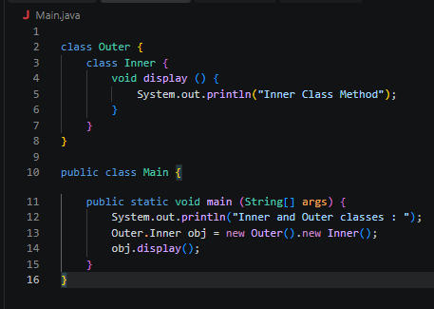
Output Screenshots | 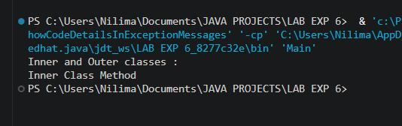
Exercise Qns | Q1. Create a Vehicle program where an inner class displays vehicle details and  anonymous class performs an action.  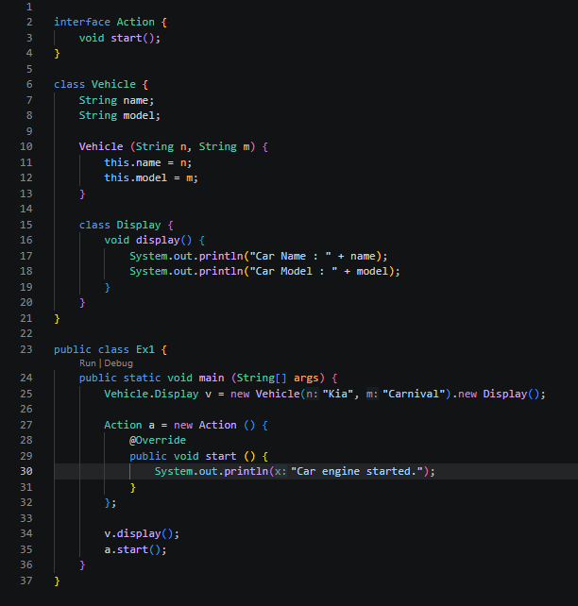  Q2. Develop a Food Delivery Application where an inner class handles order  details and anonymous classes handle delivery status updates.  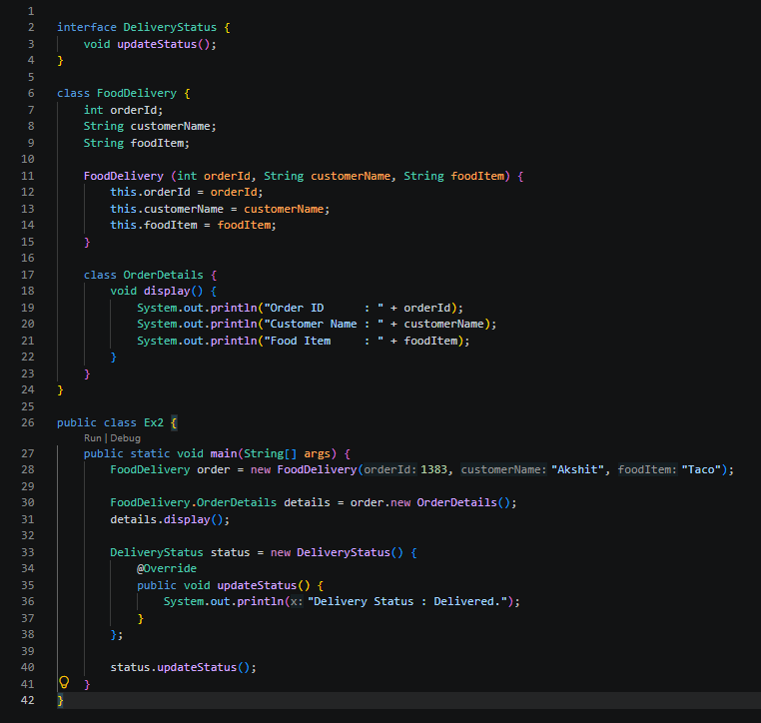
Output Screenshots | 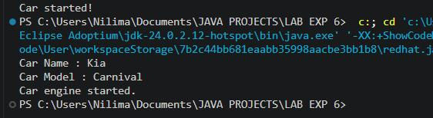  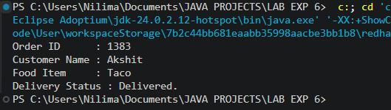
Conclusion | This assignment helped in understanding the concepts of inner classes and anonymous classes in Java. It demonstrated how an inner class can access the members of its enclosing class to improve code organization and encapsulation, while an anonymous class can provide a one-time implementation of an interface or abstract class without creating a separate class. The implementation improved my understanding of object- oriented programming concepts, event handling, and code reusability. These concepts are widely used in Java GUI development, event-driven programming, multithreading, and real-world applications where concise and modular code is required.

